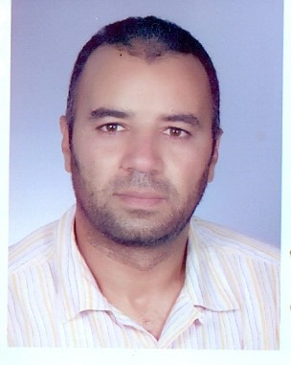 | MOUHAMED TOUJENI  Address :Omar Elmokhtar street ksar bardo city beja 9000  Tel :+(216)52861800/96158580  Email :mtoujani576@gmail.com

OBJECTIVE

PERSONALS
- Name : Mouhamed Toujeni
- Gender : man
- Marital Status : Single
- Birth date : 04/08/1979

EDUCATION
- Tunisian baccalaureate ( June 2002)

CERTIFICATES & COURSES ATTENDED:
- .National License of Technology(network administrator)( June 2018) (from High Institute of Technology Studies I.S.E.T. BEJA)

LANGUAGE SKILLS
- Arabic : native
- English : average

COMPUTER SKILLS
- Microsoft office 2013
- Junior Java programmer
- Optic fiber connection technician
- Graphic designer(beginner)

PERSONAL QUALITIES
- Dynamic,comprehensive,cooperate

WORK EXPERIENCE
- Network administrator at ministry of culture since 04/2012
- Network administrator at Beja culture administration (since Oct 2013)
INTERESTS
- Web programming, network admin, web developer, sports…

“Your Honor, I believe my skills qualify me to be an ideal candidate for the current open Human Resource
Specialist Position in your company.

I will follow up with you to discuss the possibility of an interview, In the meantime,
Please feel free to contact me.”

